

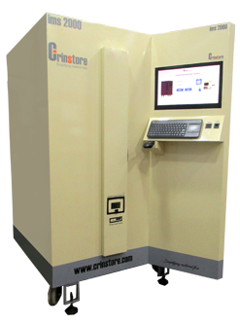

**Creintors Storage Solutions Private Limited**

Plot No.: 2, Survey No.: 22/3,

Waghawade Road,Waghawade, Belgaum-590018, Karnataka,

INDIA, Tele- Fax: 0831-2441105

[contact@creintors.com](mailto:contact@creintors.com) | [www.crinstore.com](http://www.creintors.com/)

# Table of Contents

ABSTRACT 1

1. INTRODUCTION 2

2. FEATURES 3

3. POWER ON 4

4. MACHINE INITIALIZATION 4

5. ADMIN ACTIVITIES 6

5.1. ADMIN HOME SCREEN 6

5.2. USER MANAGEMENT 7

5.2.1. View User 8

5.2.2. Add User 9

5.2.3. Update User 11

5.2.4. Delete User 12

5.2.5. E-Mail Registration 13

5.3. ITEM MANAGEMENT 14

5.3.1. Add Item 15

5.3.2. Delete Item 16

5.3.3. Load Item 17

5.3.4. Unload Item 18

5.3.5. Add Machine 19

5.3.6. View Item 20

5.3.7. View Stock 21

5.4. REPORT MANAGEMENT 22

5.4.1. Mail Reports 22

5.4.2. View Reports 23

5.4.2.1. Item Details 23

5.4.2.2. Employee Details 24

5.4.2.3. Customized Report 25

5.4.2.3.1. Monthly Report 26

5.4.2.3.2. Item Wise Report 28

5.4.2.3.3. User Wise Report 30

5.4.2.3.4. Admin Activity Report 32

5.4.2.3.5. Admin Transaction Report 34

5.4.2.4. Weekly Consumption Report 36

5.4.2.5. Item wise Weekly Consumption Report 37

5.5. CHECK IN MANAGEMENT 38

5.5.1. View Check In 39

5.5.2. Add Check In 40

5.5.3. Delete Check In 41

6. USER ACTIVITY 42

6.1. REPLACE OPERATION 42

7. USER AND ADMIN ACTIVITY 44

7.1. NEW OPERATION 44

7.2. SURRENDER OPERATION 47

TROUBLESHOOTING 51

# ABSTRACT

This invention aims in designing and manufacturing a complete system which will ease the storage of small inserts and tools in Industries. These Compact Inserts and tools are very expensive and become a big challenge to manage the complete utilization, accountability and inventory by the respective industry. Our goal is to incorporate a machine with full proof system that efficiently manages the human-machine trades and controls all operations with logs. It also provides flexibility to handle complete database of all the transactions and provides security to the stored components and its distribution.

# INTRODUCTION

The "Insert Management System" has storage capacity of 2000 inserts. The Admin is the authorized person for adding the required details like operator details, Machine details , Insert details and the working time to the machine. After these information are added the Admin can physically load the Inserts into the machine for use.

The Operator can take a New Insert by depositing the old one, which is collected in a bin assigned for that operator. If in case the operator do not have used Insert he can contact Admin , who in turn can give him a new Insert for use.

All the actions performed by the Operator and Admin are logged in the system and are available as reports. The system has capability to sent reports on particular scheduled day through E-mail. The system provided continues alerts on the inventory status to the Admin through SMS.

The IMS provides a control on Inventory and its usage and help the industry to plan their inventory of Inserts and strictly monitor their usage.

# FEATURES

* Storage capacity of 2000 Inserts.
* Used Insert collection cartridges for each operator.
* Each Inserts are protected by storing in plastic box of size : 35 x35 x12 ht
* 24X7 secured and controlled access to the registered users.
* No Supervisor required as easy to operate.
* Login through any of the following registered mode :
  + RFID
  + Finger Print
  + Login ID and Password
* Automatic Data logging of every operation performed.
* Automatic Inventory Maintenance.
* Customized Reports.
* Automatic PO generation. (optional)
* Messages to admin for low inventory.
* Automatic mail for daily/weekly Consumption Report.

**SPECIFICATIONS**

* Height – 1830 mm (6 ft)
* Width – 1030 mm (3.4 ft)
* Depth – 1510 mm (5 ft)
* Floor space required – 3000 Sq mm

**ELECTRICAL REQUIREMENTS**

* Electrical: 230 VAC (+/-10) ; 50 Hz
* Maximum Operating Amperes – 4 amps

# POWER ON

1. On the power switch panel, set all switches to the OFF positions.
2. Plug the machine into a 230 volts 50Hz, 5 Amps DEDICATED receptacle. Set all power switches to the ON position.
3. Leveling the Machine: This step is very important for the proper function of machine. The four leveling screws in the legs are the means of leveling the machine. After positioning the machine, level machine in front to rear and right to left directions. After leveling, turn front right (lock side) leveling screw in about one-half turn to drop this corner slightly to make the door easier to close and lock.

* AS PRE REQUISITE, A DISTANCE OF 6 INCHES SHOULD BE MAINTAINED FROM THE ENCLOSURE TO THE WALL FOR SAFE VENTILATION.

# MACHINE INITIALIZATION

1. **System Initialization**

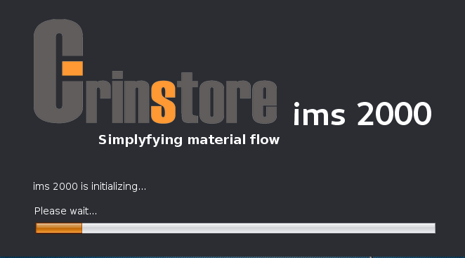

This screen displays the status of complete system Initialization. After Initialization

is successful Login screen appears.

1. **Login Screen**

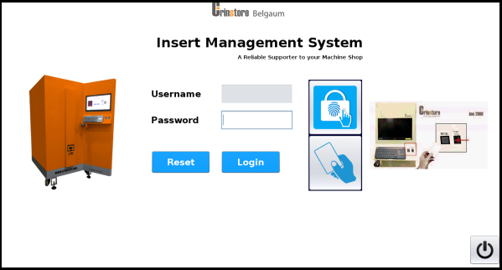

This screen provides three options for authentication of a user / admin.

* + **RFID Login:**

Swipe RFID at RFID reader. If the RFID is registered, user name will appear,

enter the password and click on Login to move to next screen.

* + **Finger Print Login:**

First Select the Finger Print option from the images on right side of screen.

Place your registered finger on fingerprint module and click on OK. If finger

is matched the next screen will appear.

* + **User name and Password:**

First Select the RFID option from the images on right side of screen. Enter user name and password and click on Login to move to next screen.

**NOTE:**

1. Unregistered user or RFID or Finger will get appropriate messages
2. If user fails to login more than three times with RFID then the users RFID card is Blocked.
3. To Unblock user follow steps (4.1.3, 4, and 5)
4. Shut down button is provided to shut down the system.



# ADMIN ACTIVITIES

# ADMIN HOME SCREEN

The below screen appears after admin logs in

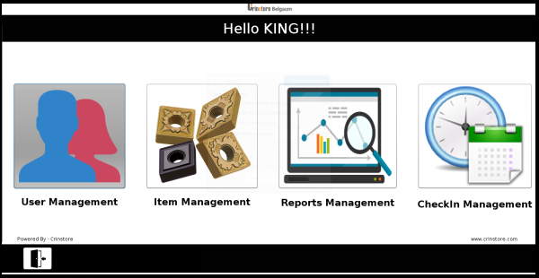

* This screen loads on Admin Login. It contains four modules.
  1. **USER MANAGEMENT**
  2. **ITEM MANAGEMENT**
  3. **REPORTS MANAGEMENT**
  4. **CHECKIN MANAGEMENT**
* Click on LOGOUT button to log out of Admin home.

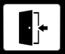

# USER MANAGEMENT

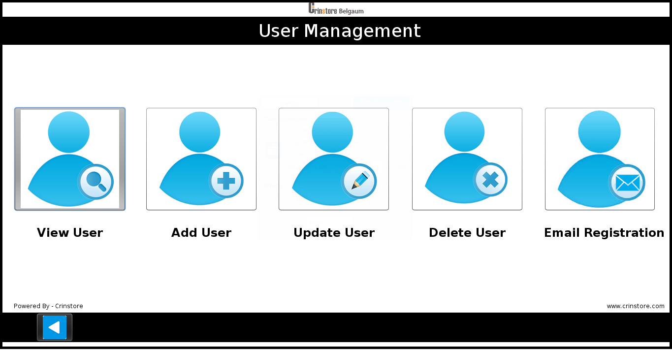

* The above screen is displayed after the Admin selects the User Management tab.
* It contains five options.

1. **View user**
2. **Add user**
3. **Update user**
4. **Delete user**
5. **Email Registration**

* Click on back tab to go Home Page



# View User

1. To view the user information click on “**View User” tab** from User Management screen and enter the user name and click on **OK**.

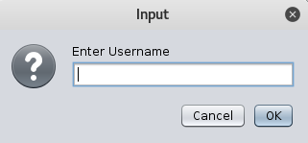

1. This screen displays all details about the User. The information will be read only that is none of the information can be edited.

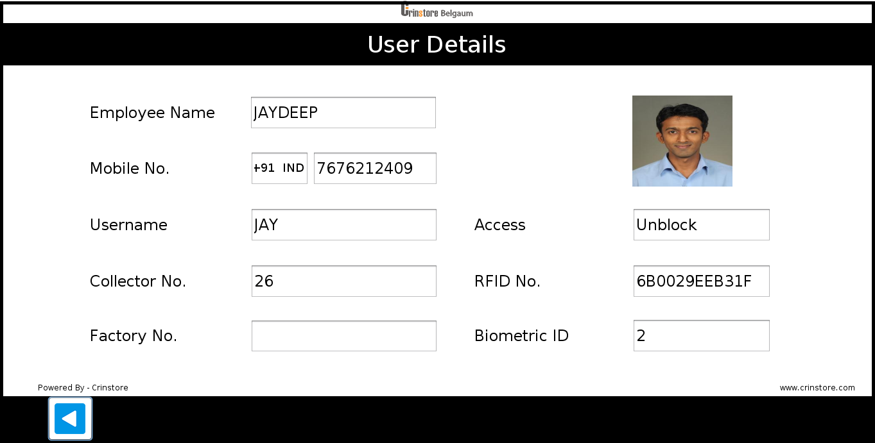

1. Click on back tab to go back on User Management screen



# Add User

1. To add New User click on “**Add User” tab** from User Management screen.



1. After click on Add User tab below screen appears.

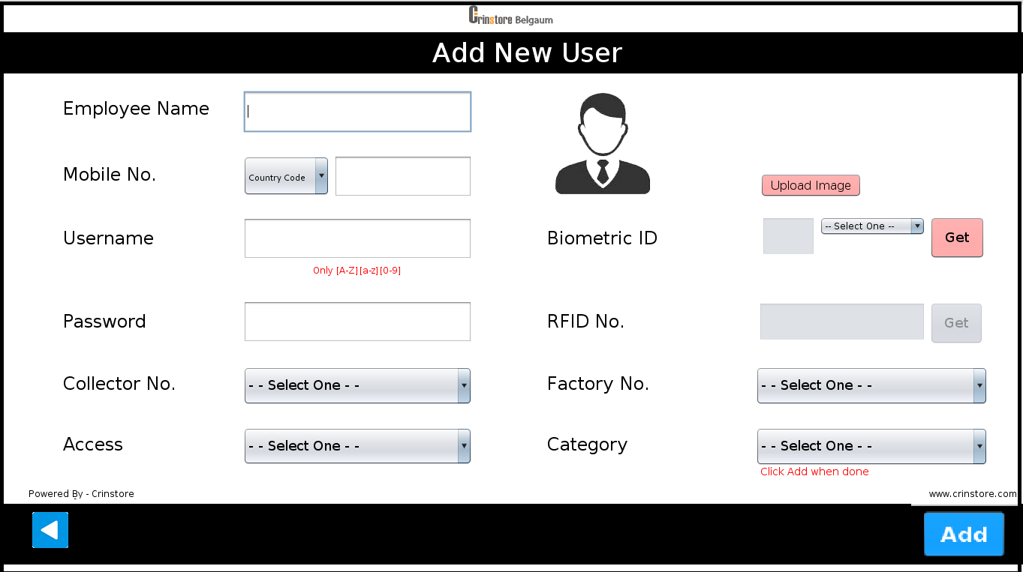

1. Fill the details of Employee Name, phone number.
2. The User name has to be filled correctly.
3. Following steps have to be followed while adding the Biometric ID of a User.
4. Select Biometric ID from the drop down menu.
5. Click on Get tab and press OK.
6. User has to place his finger on the finger print scanner till the enrollment gets

completed.

1. Following steps have to be followed to get RFID number of a user.
2. Click on **Get** tab.
3. Swipe RFID tag of the user on the RFID Reader.
4. Following steps have to be followed to add user image
5. Click on Upload image tab
6. Select image and click on ok.
7. Select Category from the drop down menu i.e. Admin or User.
8. Select collector no from drop down menu to collect used items.
9. Select factory no from drop down menu.
10. Click on Add tab if all field data is correct.



1. After click on **Add** you get confirmation message.

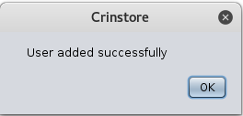

1. Click on back tab to go Home Page.



# Update User

1. To edit user details click on **“Update User” tab** from User Management

Screen.

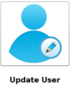

1. Enter the user name whose details have to be Update.
2. A screen with the User details appears.

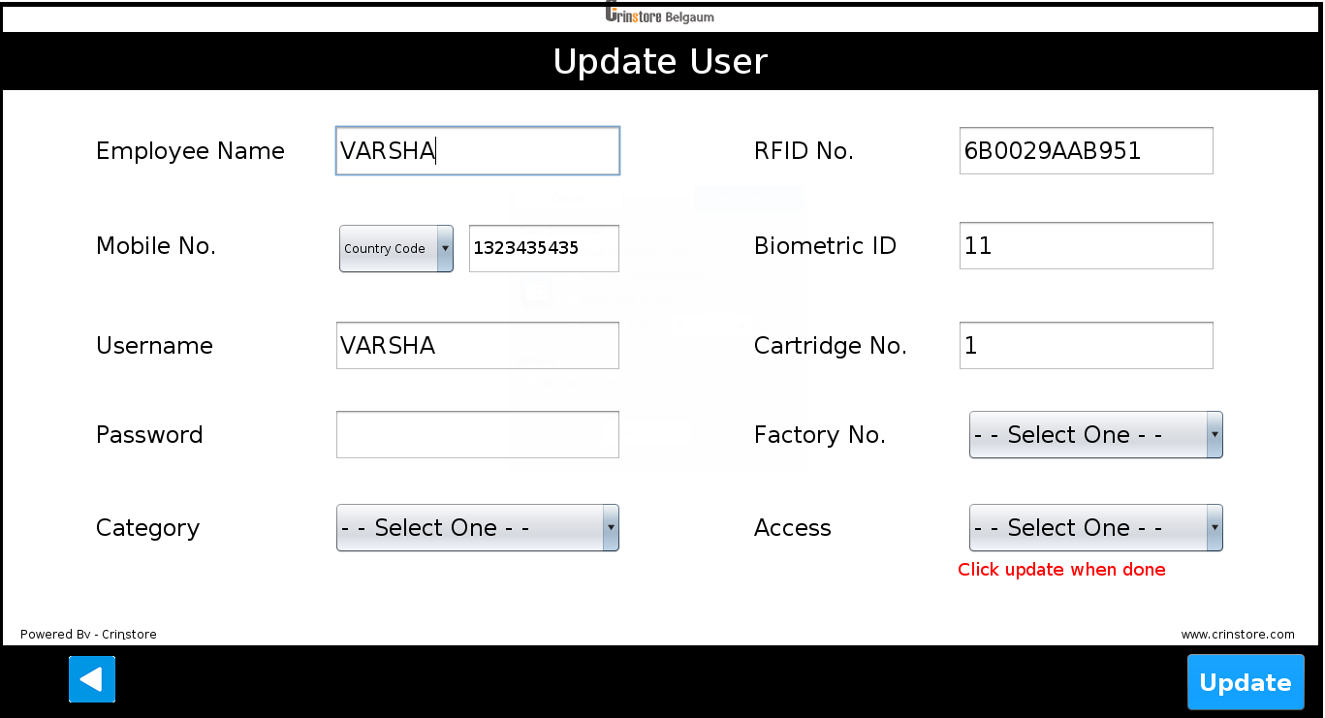

1. An **Access** field is provided to Block or Unblock the User.

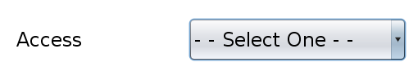

**Note -** Whenever user is block then admin has to unblock the user using the

update user option.

1. Click on **Update** button to confirm the changes.



# Delete User

1. To Delete User click On “**Delete User” tab** from User Management Screen.

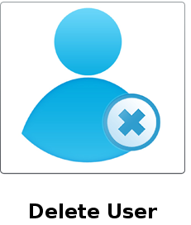

1. Enter User name and click **Ok.**



1. A screen with the User details appears.

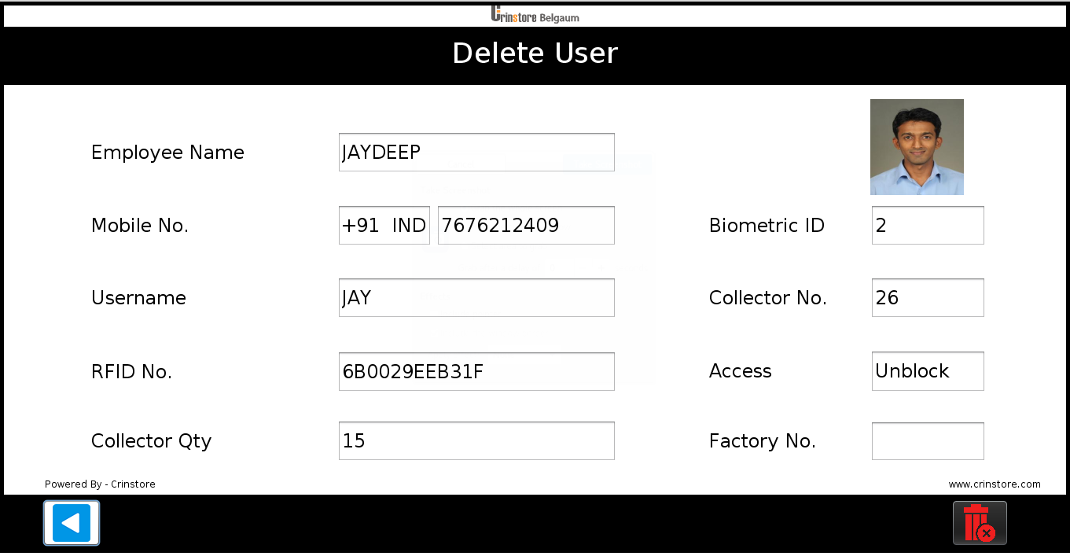

1. Click on Delete tab icon.



1. After click on delete you get confirmation message.
2. The User details are deleted from the database.

# E-Mail Registration

1. To register receiver and sender email click on “**Email Registration”** from user management screen.



1. After selecting Email Registration below screen appears.

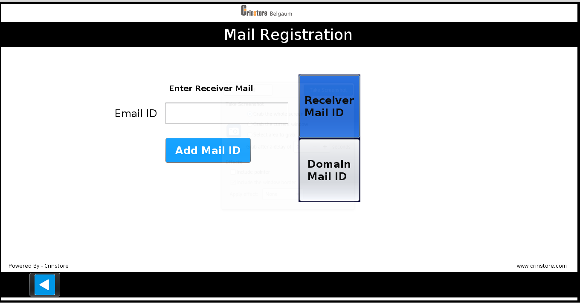

1. Select receiver mail ID tab to add receiver mail id
2. Click on Add Mail ID tab.

**Note- Any number of receiver Email IDs can be added.**

1. Click on Domain Mail ID tab to add Sender mail ID.

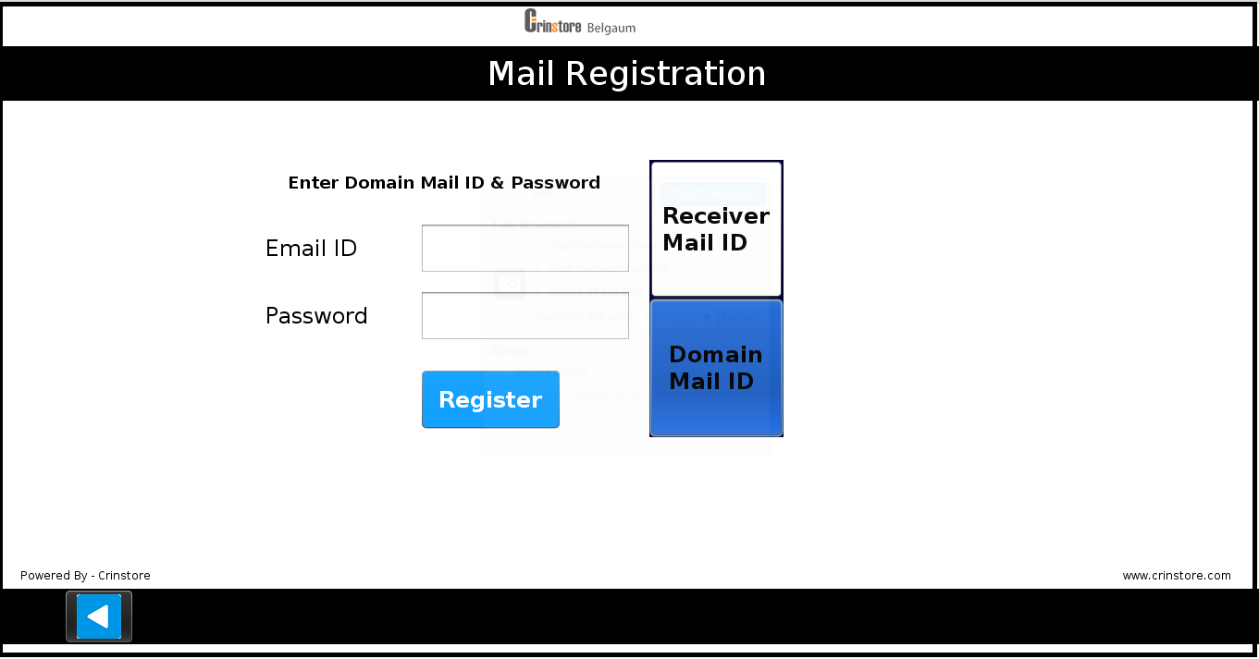

1. Enter email ID, Password And click on Register tab to add sender mail ID.

# ITEM MANAGEMENT

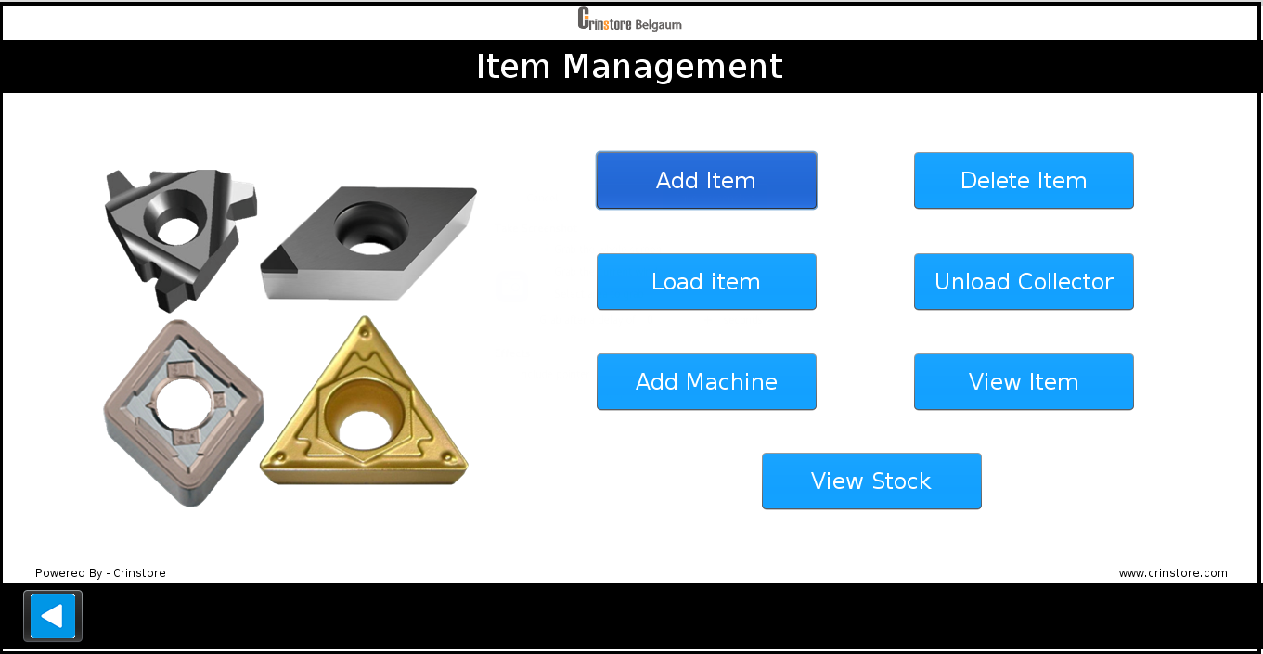

* The above screen is displayed after the Admin selects the Item Management tab.
* It contains seven option as

1. **Add Item**
2. **Delete Item**
3. **Load Item**
4. **Unload Collector**
5. **View Item**
6. **View Stock**

* Click on back tab to go Home Page



# Add Item

1. This screen is provided for the Admin to add all the Item details in the system.
2. Admin clicks on the “**Add Item” tab** from Item Management Screen.

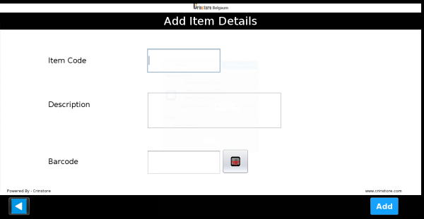

1. All the details in the above screen are mandatory.
2. Enter Item Code
3. Enter description about the Item
4. Scan Item barcode using front barcode scanner.

1. Click on **Add** tab to define new Item to machine.



1. To go back on Item Management screen click on back tab.



# Delete Item

1. This screen is provided for the Admin to delete the Item from the system.
2. To Delete Item click on “Delete Item” tab from Item Management Screen.
3. Select the Item code to be deleted.

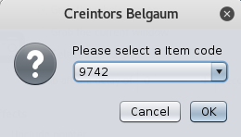

1. All the details of the Item code appears on the screen.

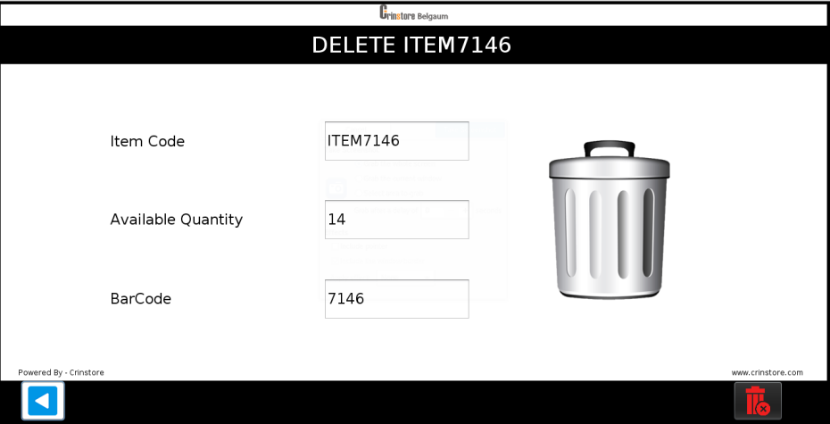

1. Click on delete icon to delete the Item details from the System.



1. A confirmation message appears in order to reconfirm if the Admin wants to delete the Item details.

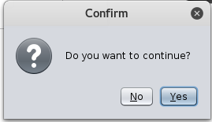

1. To go back to Item Management Screen click on Back tab.



# Load Item

1. This screen is provided for loading new physical Items in the machine.
2. To Load the Item Click on “Load Item” tab from Item Management screen.
3. The following screen appears to help the Admin to load the Items.

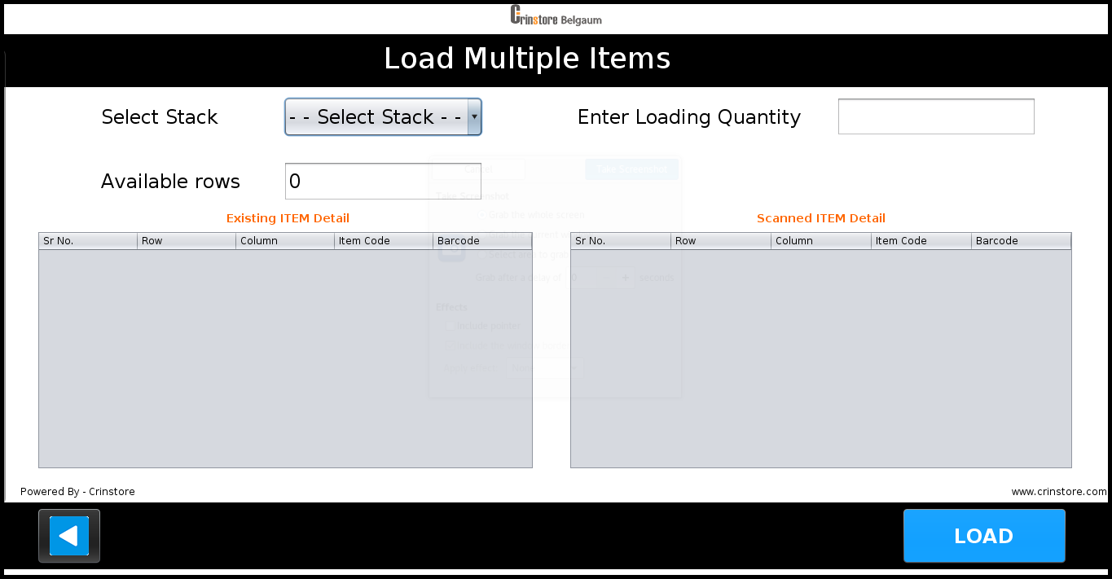

1. Select stack number, enter loading quantity according to available rows and click on **Load.**
2. Open the door
3. Load the Items
4. Close the door and click OK
5. Scanning starts for the loaded items.
6. After scanning is stopped it checks the previous loaded and newly loaded Item quantity and display proper message.
7. If there is quantity mismatch /any error
8. Click on Open.
9. Open the door and load the item as per existing item detail.
10. After completing Successful loading it gives proper message.
11. To go back on Item Management screen click on Back tab.



# Unload Item

1. This screen is provided for the Admin to Unload (empty) the user used item collector.
2. To Unload the Items click on **“Unload Item” tab** From Item Management screen.
3. Enter the User name and click on **OK**



1. The following Screen appears which displays the detail of the Collected Quantity.

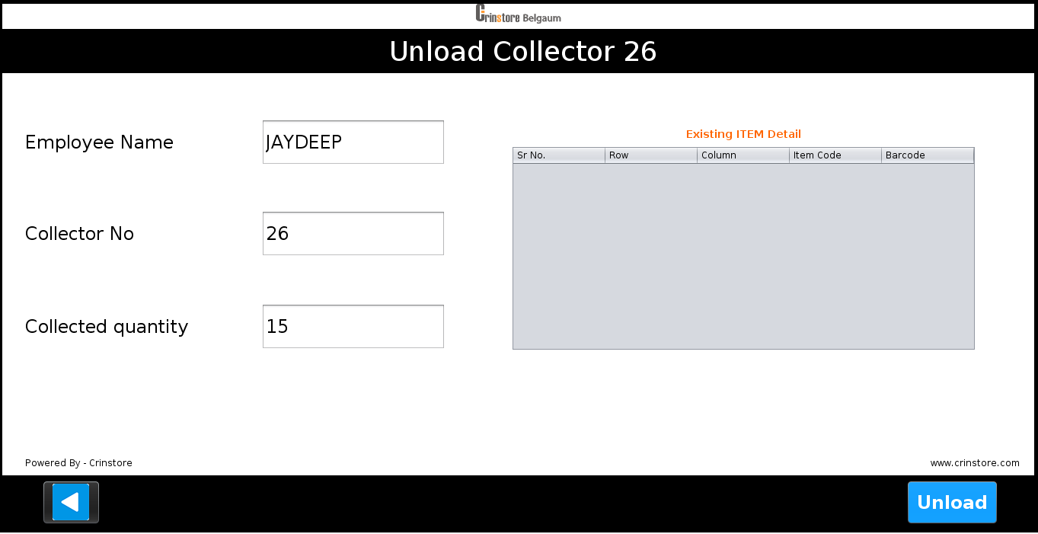

1. Click On **Unload**
2. Open The Door.
3. Pull the collector to be unloaded out and remove all the boxes from both the cartridges.
4. Put the collector back after making it empty.
5. Close the door.
6. After closing the door it starts scanning to insure existing stock is not tampered

**Note -**

* **Both collector should be emptied at the same time.**
* **Maximum capacity of collector is 15.**

1. To go back on Item Management screen click on Back tab.



# Add Machine

1. This screen is provided for the Admin to add new Machine details in the system.
2. Click on **“Add Machine” tab** from Item Management Screen.
3. The following screen is displayed to add machine details.

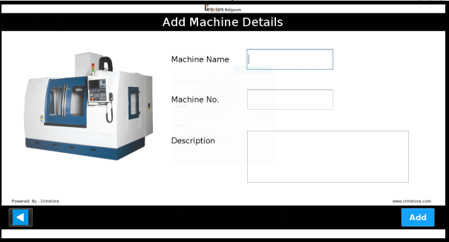

1. Enter all the details correctly.

1. Click on **Add** tab to add the Machine details in the System.



1. To go back to Item Management Screen click on Back tab.



# View Item

# 

1. This Screen is provided for the Admin to view Item details in the System.
2. To view Item details click on **“View Item”** **tab** from Item Management screen.
3. Enter the Item code and click on **OK**.
4. The following screen appears which will display all the details about the Item.

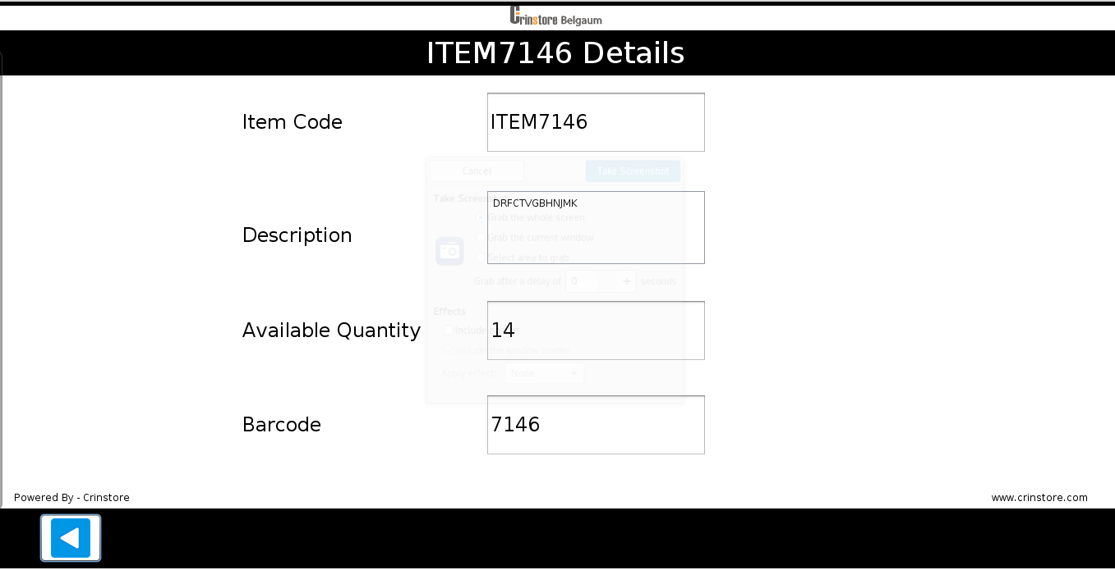

1. To go back to Item Management screen click on Back tab.



# View Stock

1. This Screen is provided for the Admin to view Stock details in the System.
2. To view Stock details click on **“View Stock”** **tab** from Item Management screen.

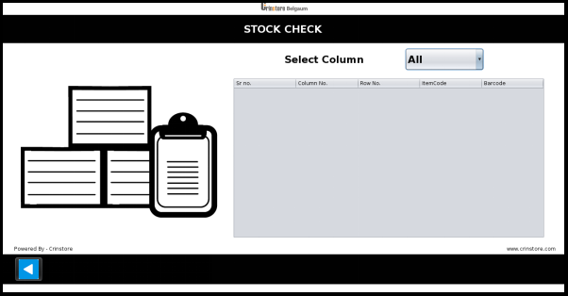

1. Select Column number.

1. It displays all the details about the stock for selected column.
2. Column number
3. Row number
4. Item code
5. Barcode
6. To go back to Item Management screen click on Back tab.



# REPORT MANAGEMENT

1. The Report Management tab is provided to direct Admin to Reporting section.



1. The Reporting section displays following screen :

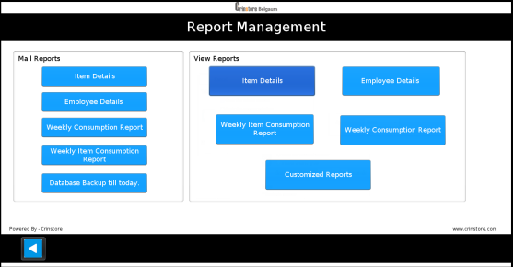

This Screen contains two sections one is for mail reports and second is for view reports

# **Mail Reports**

If admin wants to send the report to the registered mail id. That time this option is useful to mail reports.

1. **Item Details**
2. **Employee Details**
3. **Weekly Consumption Report**
4. **Weekly Item consumption report**
5. **Database backup till today**

Admin can send the mail of above five types of reports.

To send the mail just click on type of report which you want to send.

# **View Reports**

These reports are :

* **Item Details**
* **Employee Details**
* **Customized Reports**
* **Weekly Consumption Report**
* **Weekly Item Consumption Report**

# **Item** Details

1. To Get Item Details click on the **“Item Details” tab** on the Report Management screen.
2. The Report opens and displays following details :

* Item Number
* Description Of Item
* Barcode Of Item
* Available Quantity Of that Item

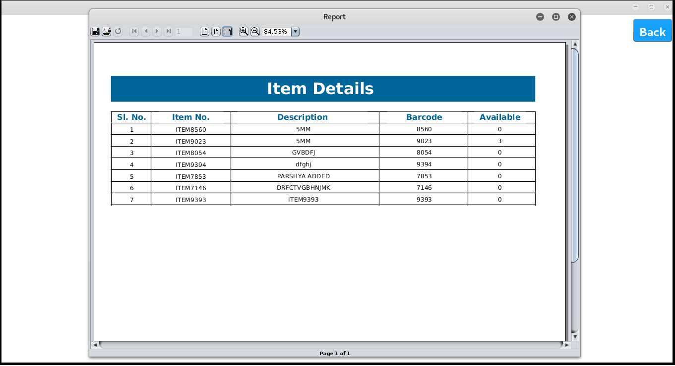

1. To go back to Report Management Screen click on **Back** tab.



# Employee Details

1. To Get User Details click on **“Employee Details” tab** on Report Management screen.
2. The Report opens and displays following details :

* Employee Name
* Factory Number
* User Name
* Collector Number
* Type Of Access

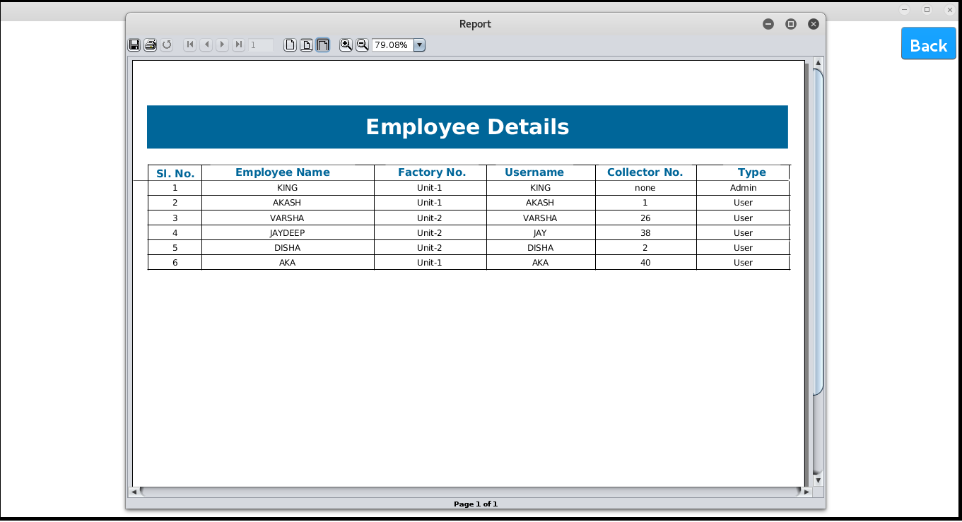

1. To go back to Report Management Screen click on Back tab.



# Customized Report

1. This screen loads on selection of **“Customized report” tab** From Report Management screen.
2. The Customized Reporting section displays following screen

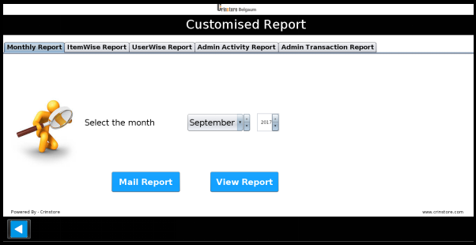

1. This Screen contains six different Tabs for six Reports

* **Monthly Report**
* **Item Wise Report**
* **User Wise Report**
* **Admin Activity Report**
* **Admin Transaction Report**

1. To go back to Report Management screen click on **Back** tab.



# Monthly Report

1. To get Monthly Report select **“Monthly Report”** tab from Customized Report.
2. Select Month, Year and click on **View Report tab**.



1. After clicking on **View Report** tab a confirmation message appears.

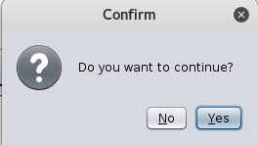

1. If you want to continue click on Yes else click on No.
2. Click on Mail Report to send the report to registered mail id.

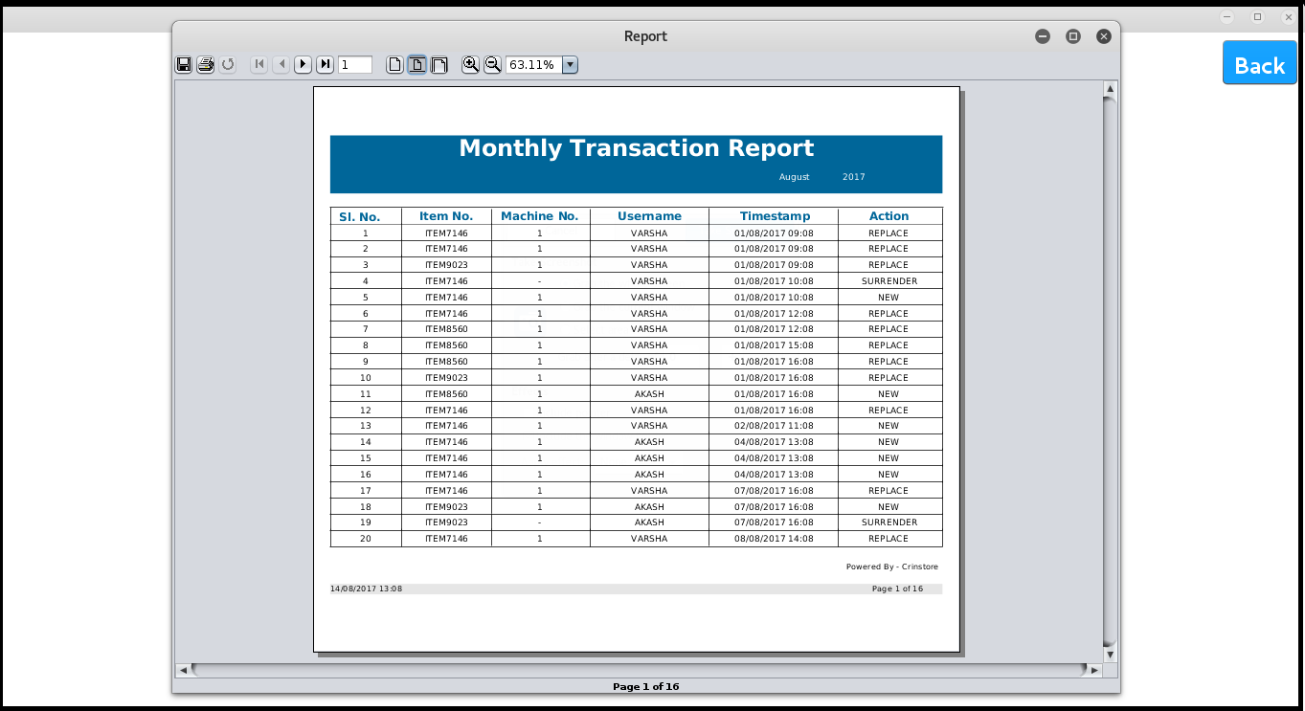

1. The Report opens and displays following details :

* Item Number
* Machine Number
* User Name
* Time stamp
* Action Taken

1. To go back on Report Management Screen click on **Back** tab.



# Item Wise Report

1. To get Item wise Report select **“Item Wise Report”** tab from Customized Report.

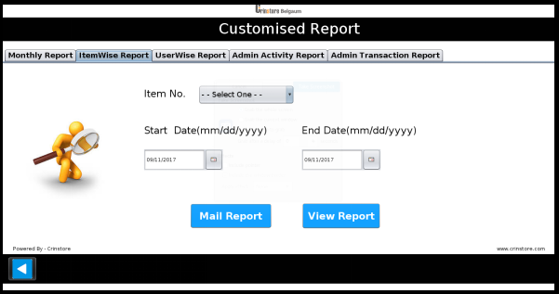

1. Select Item number, start date, end date and click on **Get Report** tab.

1. After click on **“Get Report”** tab a confirmation message appears.



1. If you want to continue click on Yes else click on No.
2. Click on Mail Report to send the report to registered mail id.

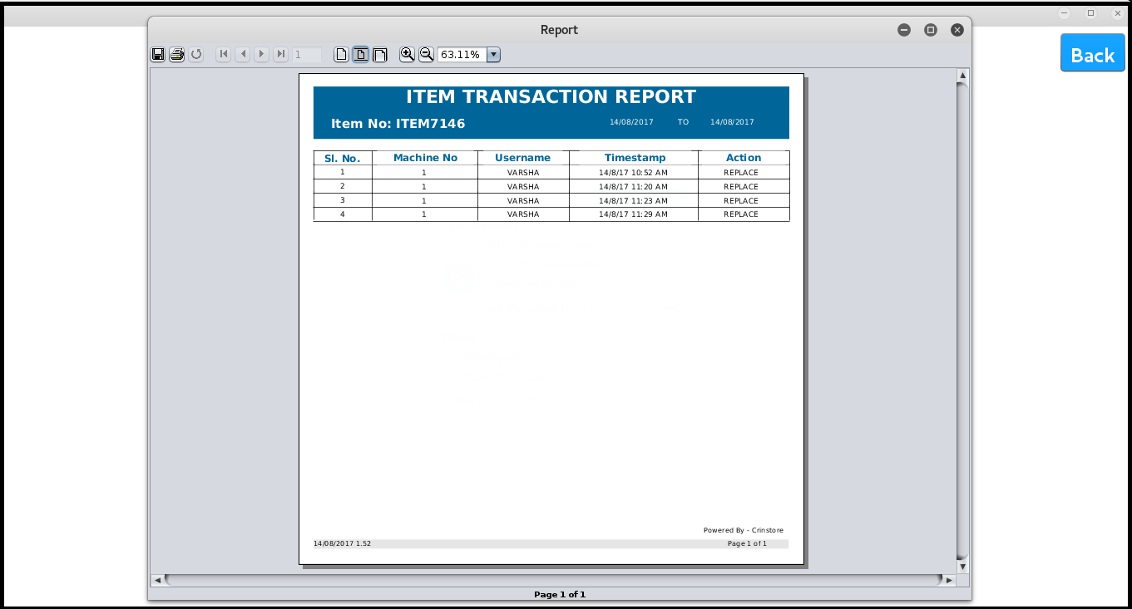

1. Report opens and displays

* Machine Number
* User Name
* Time stamp
* Action Taken

1. To go back on Report Management screen click on **Back** tab.



# User Wise Report

1. To get User wise Report select **“User Wise Report”** tab from Customized Report

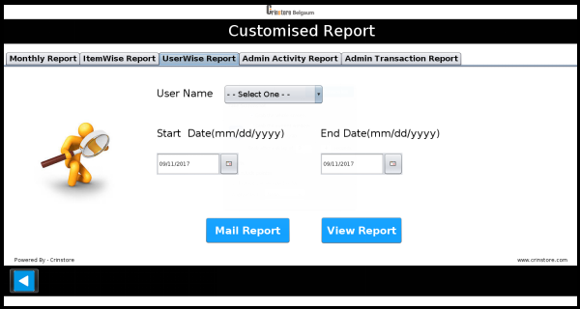

1. Select user name, start date, end date and click on **View Report** tab.

1. After click on **View Report** tab a confirmation message appears.



1. If you want to continue click on Yes else click on No.
2. Click on **Mail Report** to send the report to registered mail id.

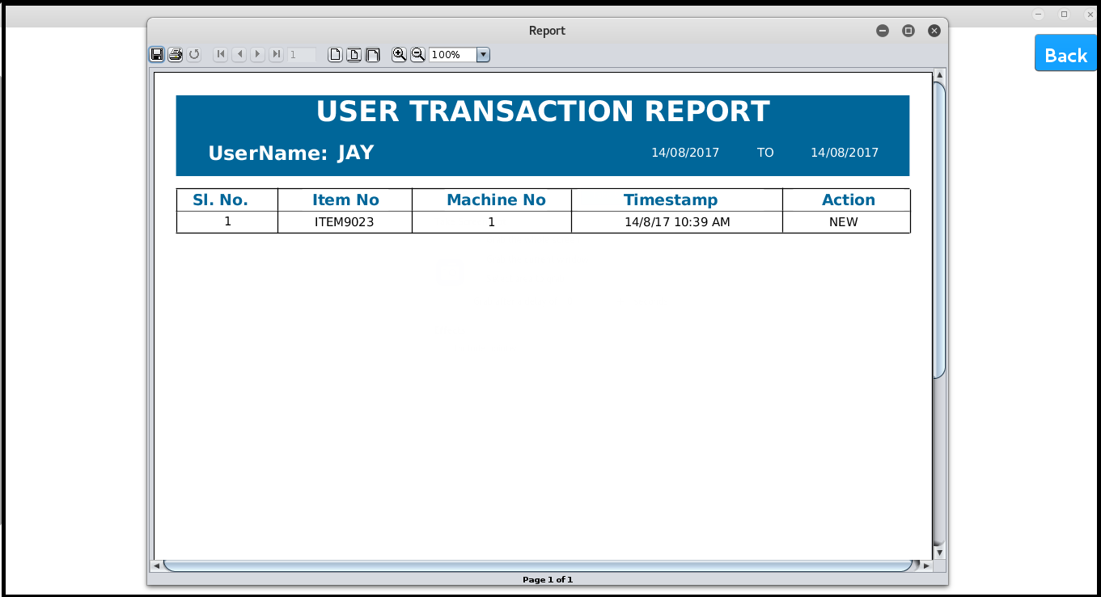

1. Report opens and displays

* Item Number
* Machine Number
* Time stamp
* Action Taken

1. To go back on Report Management screen click on **Back** tab**.**



# Admin Activity Report

1. To get Admin Activity Report select **“Admin Activity Report”** tab from Customized Report.

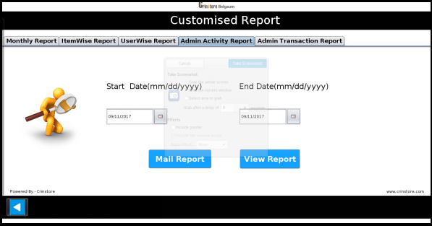

1. Select start date, end date and click on **View Report** tab.
2. After click on **View Report** tab a confirmation message appears.



1. If you want to continue click on Yes else click on No.
2. Click on **Mail Report** to send the report to registered mail id.

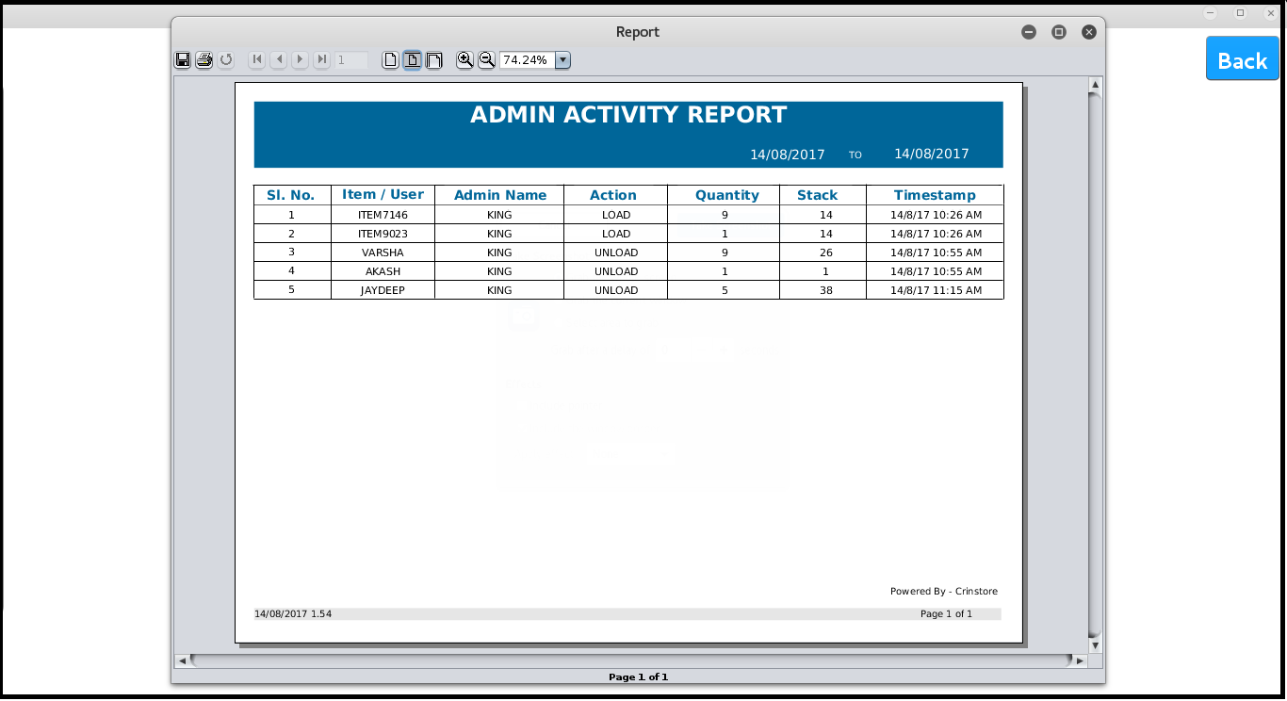

1. Report opens and displays

* Item Number
* Admin Name
* Action Taken
* Quantity
* Stack
* Time Stamp

1. To go back on Report Management screen click on **Back** tab.



# Admin Transaction Report

1. To get Admin Transaction Report select **“Admin Transaction Report”** tab from Customized Report.

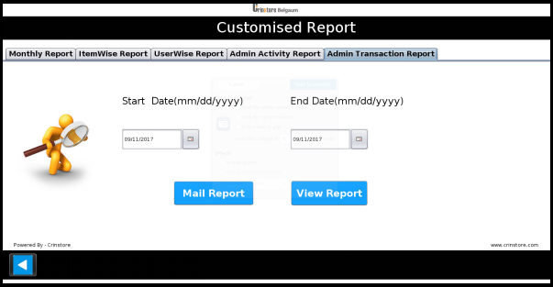

1. Select start date, end date and click on **Get Report** tab.
2. After click on **Get Report** tab a confirmation message appears.



1. If you want to continue click on Yes else click on No

1. Click on **Mail Report** to send the report to registered mail id.

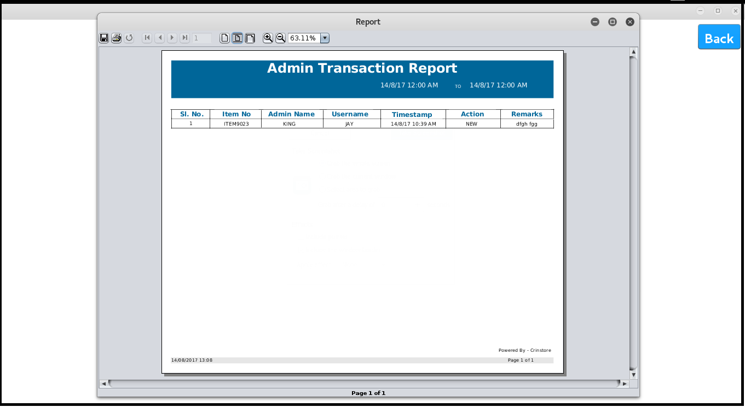

1. Report opens and displays.

* Item Number
* Admin Name
* User Name
* Time stamp
* Action
* Remark

1. To go back on Report Management screen click on **Back** tab.



# Weekly Consumption Report

1. To generate weekly Report click on **“Weekly Consumption Report”** From Report Management Screen.

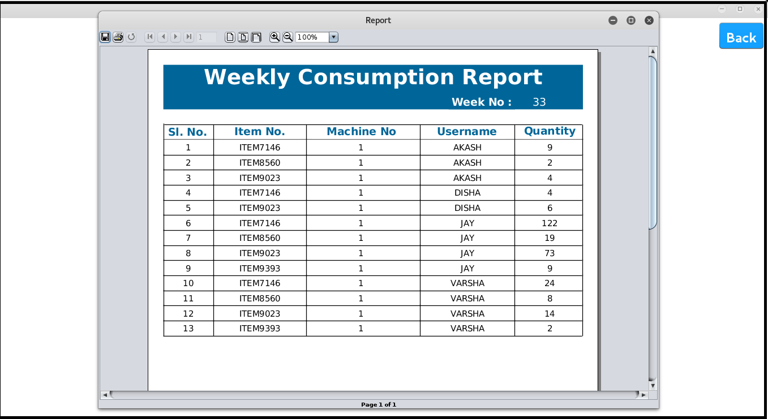

1. Report open and displays

* Item Number
* Machine Number
* User Name
* Quantity

1. To go back on Report Management screen click on **Back** tab.



# Item wise Weekly Consumption Report

1. To generate Item wise weekly report click on **“Item wise Weekly Report”** tab From Report Management screen.

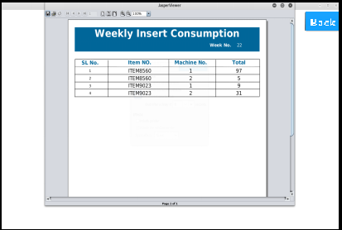

1. Report open and displays.

* Item Number
* Machine Number
* Total Insert

1. To go back on Report Management screen click on **Back** tab.



# CHECK IN MANAGEMENT

1. This screen loads on selection of “**Check IN Management”** From Admin home. And helps admin to define the working /operating hours of the machine.

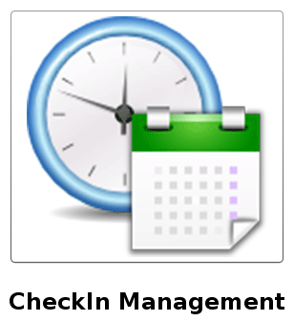

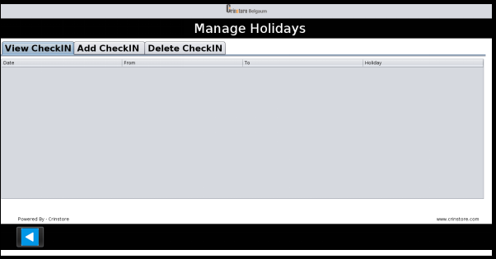

1. This screen contains three options
2. View Check In
3. Add Check In
4. Delete Check In
5. Click on back tab to go Admin Home.



# View Check In

1. This screen loads on selection of **“View Check In”** in Check in Management

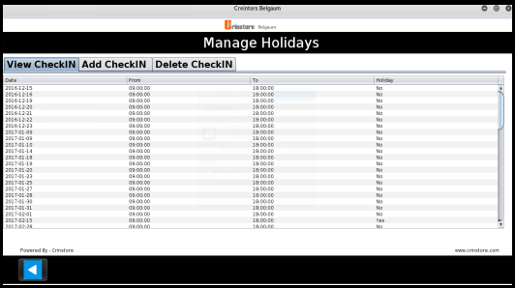

1. This displays

* Check In Date
* Start Time
* End Time
* Holiday

1. To go back to check In Management screen click on **Back** tab.



# Add Check In

# 

1. This screen loads on selection of **“Add CheckIn”** From Check in Management.

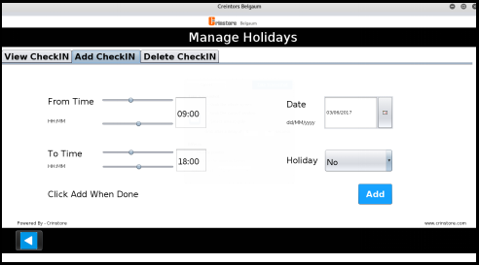

1. To Add Check In add below details

* Date
* From Time
* To Time
* Holiday

1. Click on **Add** to Add Check In



1. To go back to Check In Management screen click on Back tab



# Delete Check In

1. To Delete Check In Click On **“Delete Check In”** From Check In Management

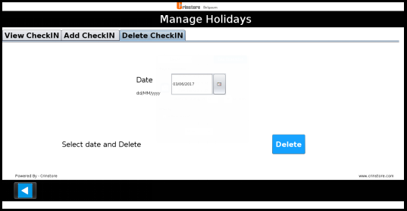

1. Select Date and click on Delete.



1. To go back to Check In Management screen click on Back tab.



# USER ACTIVITY

User have an authority to perform replace operation without an admin. User can also performs new and surrender operation but admin is mandatory for these two operation .

# REPLACE OPERATION

1. User has to Log in the system.



User Logs in the system using any of the following three ways :

* **RFID Login:**

Swipe RFID at RFID reader. If the RFID is registered, user name will appear then enter

the password and click on Login to move to the next screen.

* **Biometric Login:**
* Select the Biometric option from the images on right side of screen.
* Place your registered finger on fingerprint module and click on **OK**.
* If finger is matched the next screen will appear.
* **Manually enter User name and Password:**
* First Select the RFID option from the images on right side of screen.
* Enter user name and password and click on Login to move to next screen.

1. After login below screen appears :

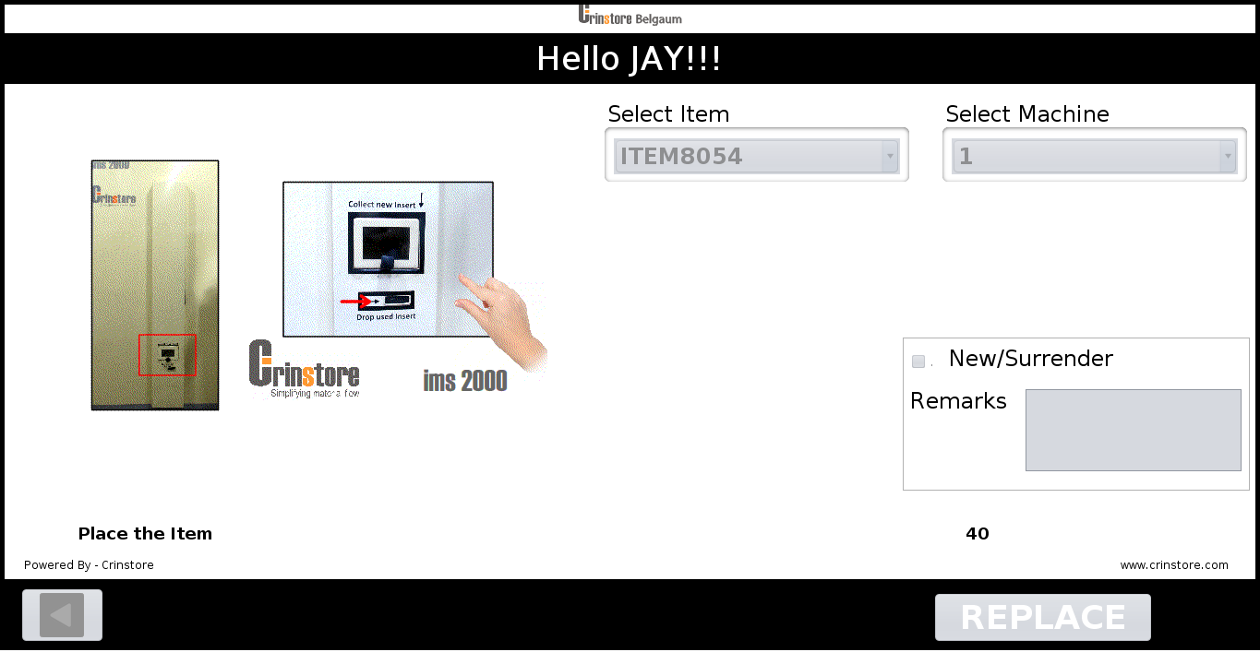

1. Select item and Machine and click on **Replace**



1. If selected Item is not available in the system then it gives appropriate message

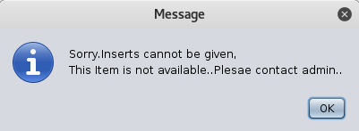

1. After click on **Replace**
2. Wait till door opens to drop used item.
3. Place the Box and click on **OK .**
4. Wait till you receive New item.

Note: - If user do not place Box, “Box not received” message appears on screen and Door is closed.

(CAUTION: Please do not put Box while door is closing.)

# USER AND ADMIN ACTIVITY

User can also perform New and Surrender Operation but Admin is Mandatory for these two operation. Without Admin login user cannot perform New Operation or Surrender operation

# NEW OPERATION

1. First user has to Login



1. After user login following screen appears

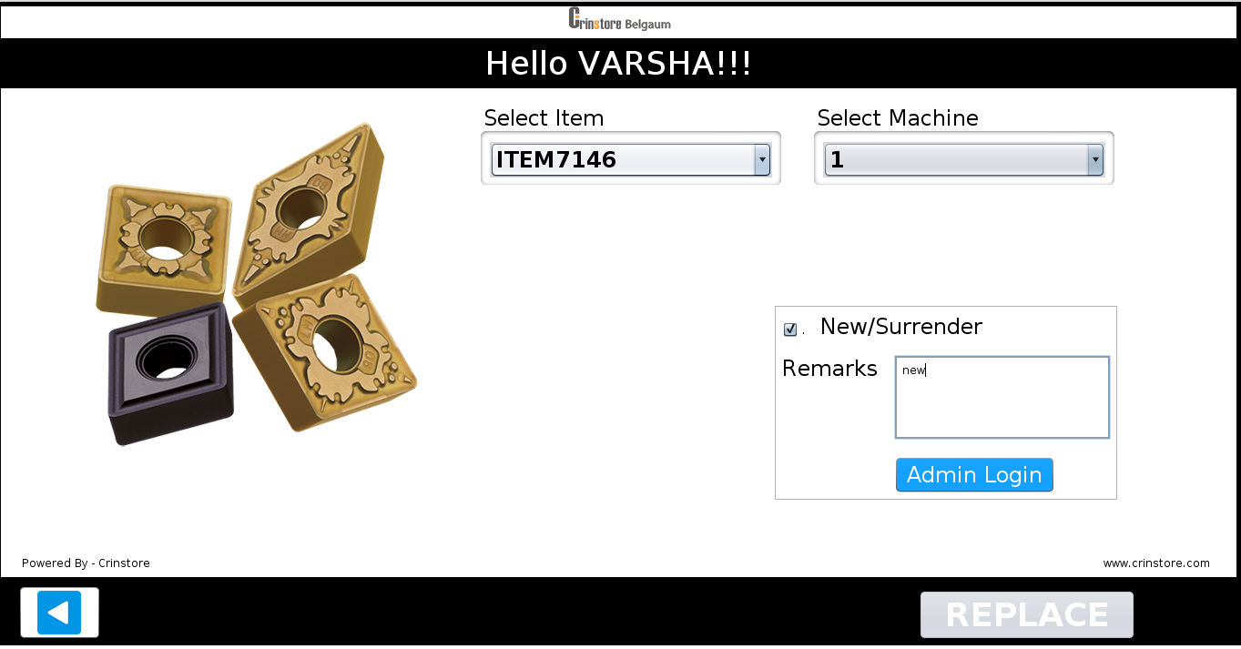

1. Select item which you want
2. Select machine number
3. Mark **New/Surrender** and enter remark

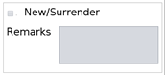

1. Admin Login button appears. Click on Admin Login

1. Admin has to login.
2. After Admin login below screen appears.

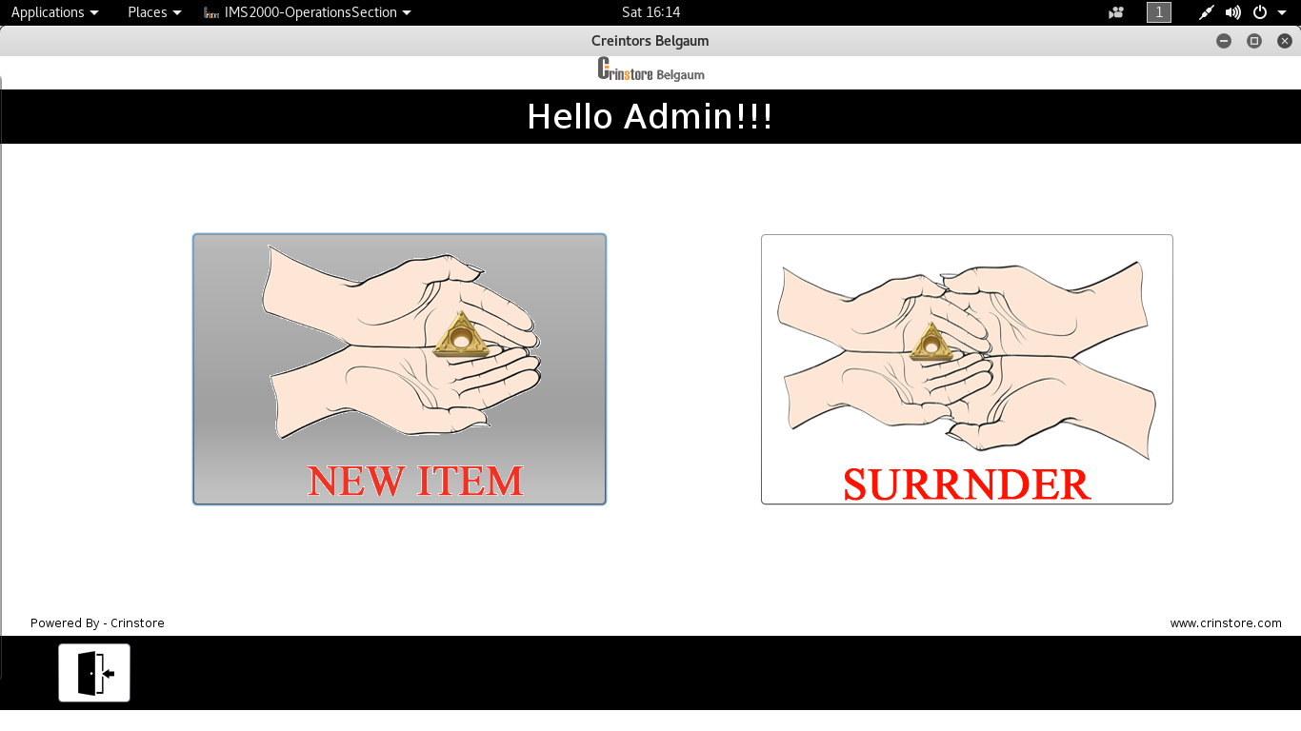

1. If you want New item select **New item** option.



1. If you want to go back without completing New operation click on **Log out** tab.



1. After selecting New item below screen appears.

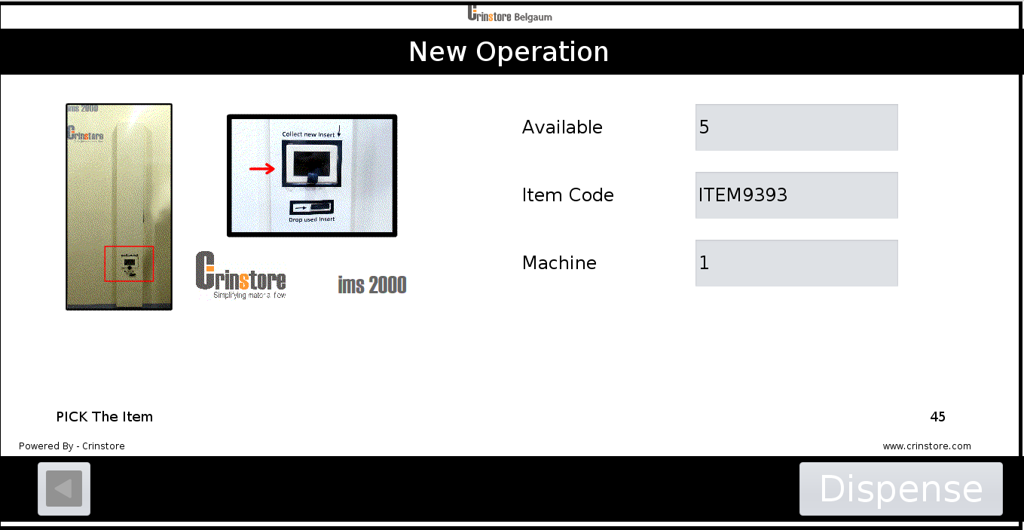

1. Click on **Dispense** for New item



1. Wait for some time and collect your new item.

1. If entered insert is not available in machine then failure message appears on screen.



1. After completing operation it goes back to login screen.

# SURRENDER OPERATION

1. First user has to Login.



1. After user login below screen appears.



1. Select item which you want
2. Select machine number
3. Mark **New/Surrender** and enter remark



1. Admin Login button appears. Click on Admin Login

1. After click on admin login admin has to login.
2. After Admin Login below screen appears.



1. To surrender your Item select **Surrender** option

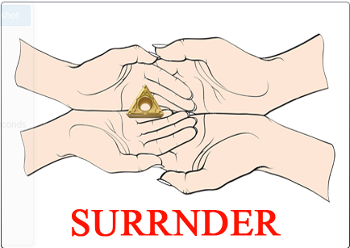

1. If you want to go back without completing surrender operation click on Back tab.



1. After selecting **Surrender** below screen appears.

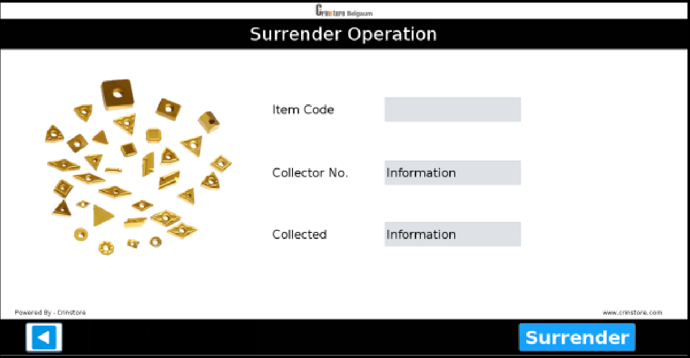

1. Click on **Surrender** to Surrender your item.



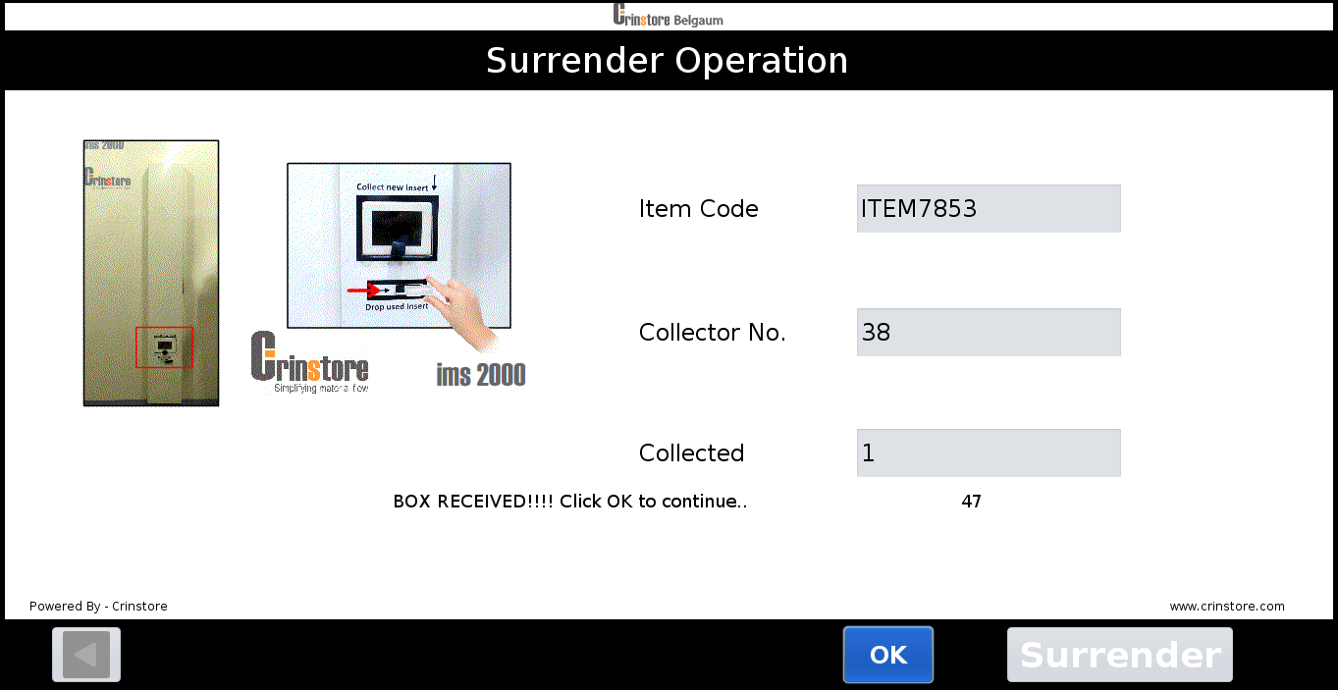

1. Wait for some time till the door opens to drop used item .
2. Place your Box and click **Ok** to continue.
3. If user do not place Box, “Box not received” message appears on screen and Door is closed.

(CAUTION: Please do not put Box while door is closing.)

1. After completing operation it goes back to login screen.

# **TROUBLESHOOTING**

|  |  |  |  |  |
| --- | --- | --- | --- | --- |
| **SL. NO.** | **MESSAGE ON SCREEN** | **LAST OPERATION / SCREEN** | **REASON** | **ACTION** |
|  | Access Denied | Login Screen | 1. Date is not   set in CheckIn Screen.   1. Login after   the time set in CheckIn screen. | Admin needs to check the date and time set in CheckIn screen and change accordingly. |
|  | Your RFID card is blocked ,Please contact Admin to unblock. | Login Screen | Three attempts of wrong  password for the RFID card. | Admin can Unblock the card in Update User screen. |
|  | No collector assigned | Unloading screen | The user  selected is of type Admin. | Select Users with user type as User for unloading |
|  | Something went  wrong !!! Please contact admin. | Initialization | System has failed to Initialize more than Three times. | ADMIN has to put his password and shut down the system.And Contact Cinstore Service department. |
|  | Something went wrong !!! Please contact admin. | NEW, REPLACE, SURRENDER, LOAD and UNLOAD | System has failed during any of the mentioned operations. | ADMIN has to put his password and shut down the system.And Contact Cinstore Service department. |
|  |  |  |  |  |
|  |  |  |  |  |
|  |  |  |  |  |